A close up of a logo

Description generated with very high confidenceA close up of a logo

Description generated with very high confidence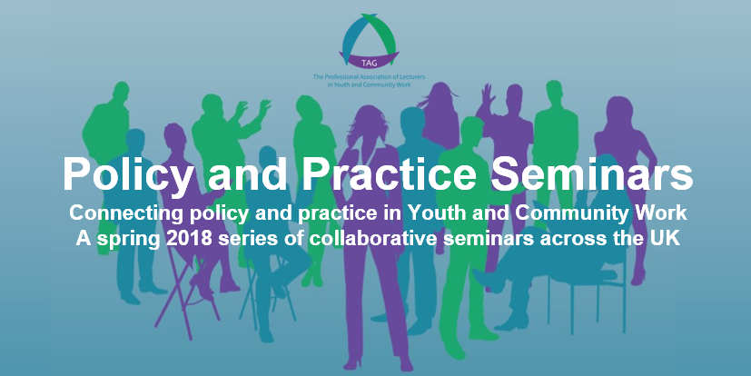

**University of Wales Trinity Saint David, Carmarthen.**

**Friday 4th May, 2018: 12.00am-4.00pm**

Hosted by the University of Wales Trinity Saint David, and co-designed with the University of South Wales, this event will include representation from practice agencies from across South Wales including Pembrokeshire Youth Service and Garth Youth & Community Project. The seminar will be repeated at the Newport Campus of the University of South Wales on 15th May.

**To book your free place visit: www.policyandpracticeseminar-carmarthen.eventbrite.co.uk**

The purpose of this seminar will be to explore practice, research and policy in relation to the growing profile given to young people’s resilience and well-being. Research is providing an increasing insight in to how health and well-being experienced during childhood and adolescence can have a long-lasting impact on the individual (Green et al 2014); and a particular emphasis has been placed on this through The Wellbeing of Future Generations (Wales) Act (2015). It is intended that this seminar will highlight a number of opportunities to carry out further research in partnership with practitioners to help inform the well-being debate and to highlight the positive role that youth and community work can make within current policy agendas. This seminar will be run at both rural (Carmarthen) and urban (Newport) venues to encourage full participation from practice agencies and cross-institutional collaboration. These will provide an excellent opportunity for students, practitioners and academics to meet and explore the different approaches to promoting well-being with young people through a reciprocal seminar approach.

**Young People, Resilience and Well-being: Issues for youth and community practice**

The Professional Association of Lecturers in Youth and Community Work is funding a series of **FREE** national, collaborative 'Policy and Practice' seminars around the UK. The aim of these seminars is to foster greater levels of collaboration between higher education institutions and practice agencies in the profiling of challenges and opportunities facing youth and community work policy and practice across the UK.



Supported by

**TAG: The Professional Association of Lecturers in Youth and Community Work** is a Charitable Company Limited by Guarantee

Charity No. 1164809. Company No. 7233585. Registered office: BG Futures, Bishop Grosseteste University, Lincoln. LN1 3DY

**Email:** info@tagpalycw.org **Tel:** 01522 404403 **Web:** www.tagpalycw.org **Find us on Twitter and Facebook via:** TAGPALYCW

